Intro

**Computer Surplus Guide - UTS**

**What is surplusing?**

1. Surplusing is the process of getting rid of stuff at System. A department admin will fill out a surplus form, and we will wipe the computer and return it to them.

*All we’re doing is wiping the computer*

2. Pick up the computer from the department admin based on the ticket you received

3. Make sure the information in red below has been filled out by the department admin

4. Remove computer from AD and SCCM (Ask an FTE to do this) 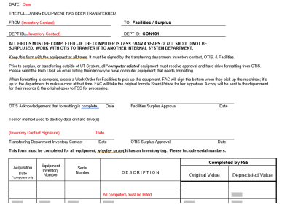

5. Wipe computers using one of three methods (see below for wiping instructions)

**A) Dell BIOS Wipe** – try this one first; if you run into issues/are not wiping a Dell computer, use a different method

**B) Surface Data Wipe** – to be used for Windows Surfaces

**C) Mac Data Wipe** – to be used for MACs.

**D) Remove Hard Drive** – last resort; if the computer cannot turn on or the screen does not work, or if the battery will explode if turned on

Dell Bios wipe

## **Dell Bios Data Wipe (For Dell Computers):**

*Ensure there is no ethernet cable plugged in; this device should not be connected to the internet*

**1. Boot into BIOS**

a. Turn on computer

b. Press F12 as soon as the computer turns on (you may have to keep clicking it until you see ‘loading bootup options.’

c. Select ‘BIOS Setup’

**2. Select the data wipe feature**

a. Open the ‘Maintenance’ tab

b. Select ‘Data Wipe’

c. Check ‘Wipe on next boot’

d. Click ‘Ok’ and then press ‘Exit’

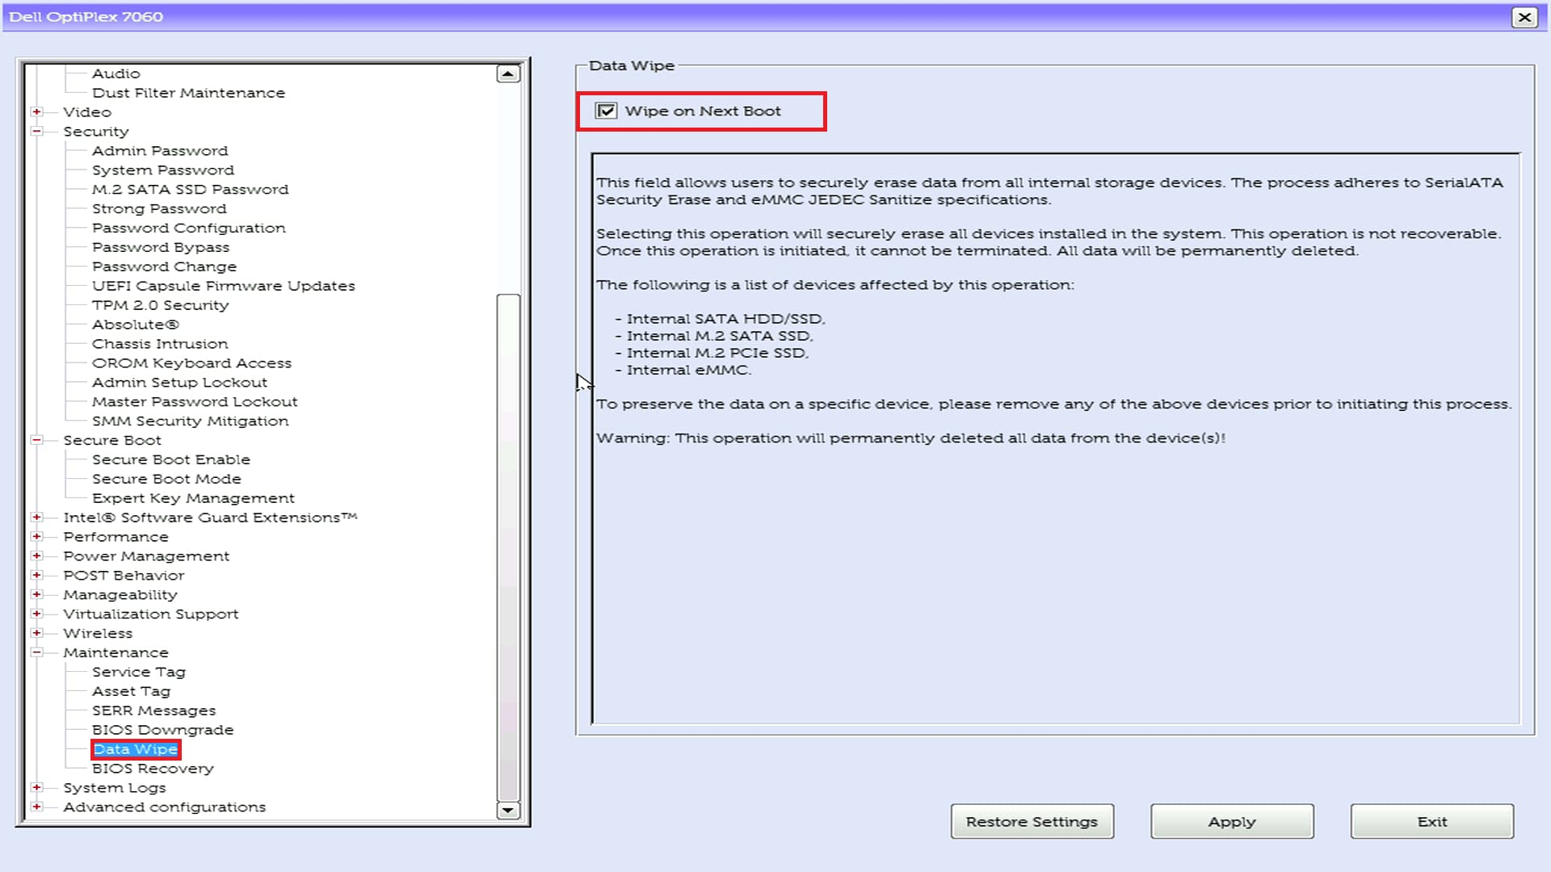

**3. Use the Data Wipe**

a. After you selected ‘Exit,’ the computer will have rebooted into the Dell BIOS wipe

b. Select ‘Continue

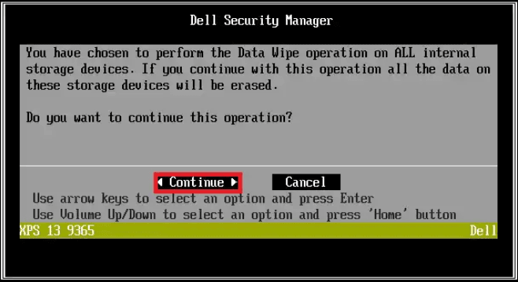

c. Select ‘Erase’

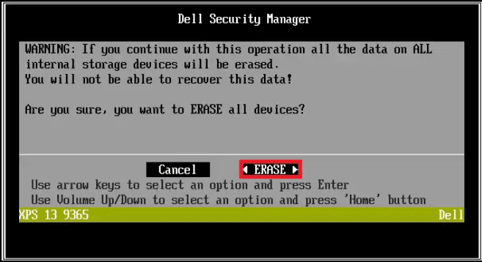

d. Once you receive the message ‘Data wipe completed successfully,’ you are good to go

e. Reboot the computer to make sure it is wiped; you should see the error message ‘no boot devices found.’ Make sure there is no ethernet connected to the computer. If it takes you back to BIOS menu, then select to boot into the hard drive to make sure there is no operating system on this computer

f. Add a sticky note with context and attach to it, the related cherwell ticket. Leave it in the workroom.

Microsoft Surface Wipe

## Surface Data Wipe (For Surface Computers)

**1. Boot up Windows BIOS**

a. Plug in a Surface Data Wipe USB

b. Turn on computer and repeatedly press the volume up button

c. You should see something like this:

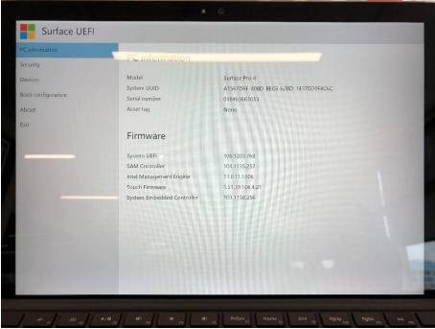

**2. Change Settings so the Surface boots into the Data Eraser**

a. Select “boot configuration” on the left menu option:

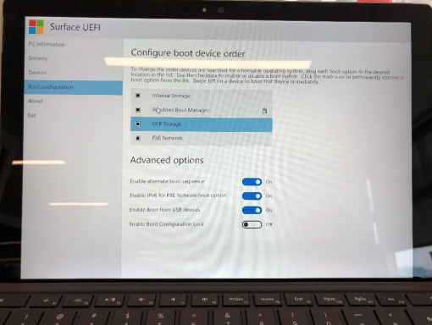

b. Uncheck all of the options except “USB Storage”

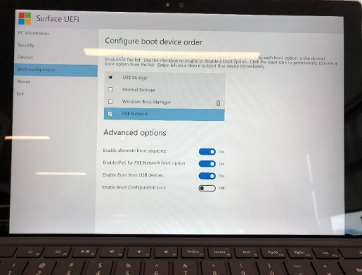

c. Select “Exit” on the left menu option

d. Click “Restart Now”

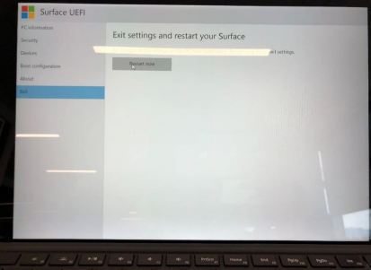

**3. Using the Surface Data Eraser**

1. After restart, there will be 2 windows pulled up, close the notepad and type ‘accept.’

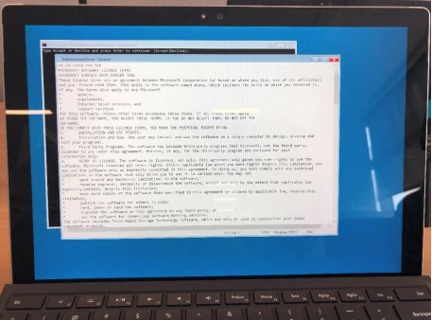

1. the surface data eraser will run for a minute, you will need to type ‘y’ and press enter once-twice
2. Restart the computer to make sure everything is deleted, it should automatically boot to the UEFI page.

Mac Surface Wipe

Manual Drive Removal

1. Power Down and Unplug the Computer

2. Open the Computer Case

3. Locate the Hard Drive

4. Disconnect the Cables from the Hard Drive

5. Remove Mounting Screws or Release Latches

6. Slide Out or Lift the Hard Drive from the Bay

7. Detach the Hard Drive from Mounting Bracket or Caddy (if applicable)

8. Close the Computer Case

9. Dispose or Destroy Data (if necessary)

